Sl No | Date | Name of the Activity | Number of Participants | Photo
1 | Date: 18th Aug 2022  Time: 7.00 pm (IST)  Venue: Online | Webinar on the topic Career Prospects in Armed Forces  Speaker  Maj. Gen. (Dr.) M.P. Singh  in collaboration with  Poshac India Foundation, New Delhi | 25 | 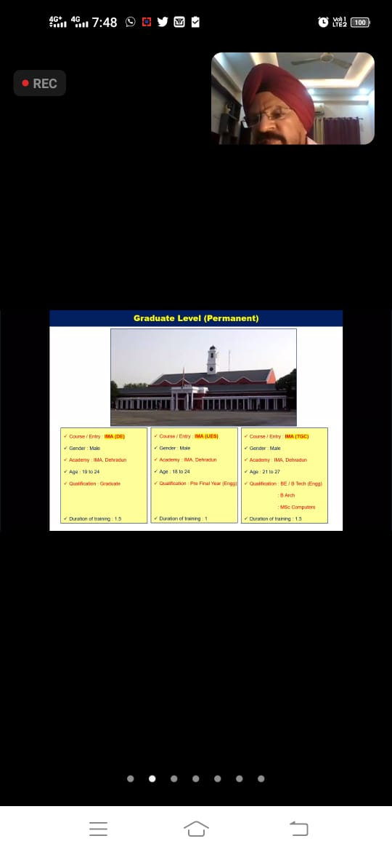
2 | 30th Aug 2022 | a Student Development Program on the topic College to Corporate in association with ICFAI Business School | 58 | 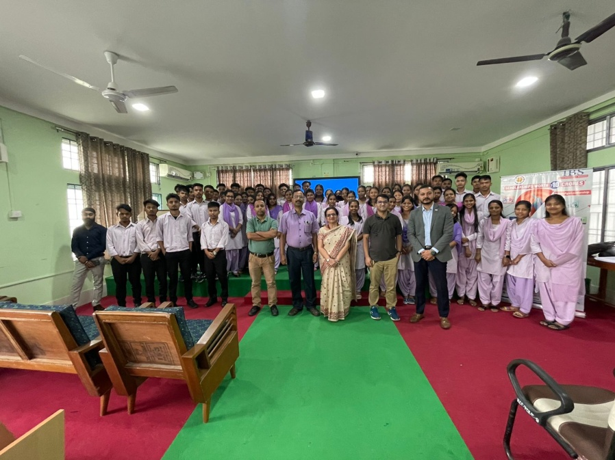
 | 12th Sept 2023 | Legal Awareness Programme on Consumer Rights in collaboration with JCI, Dibrugarh Royals.  Speaker: Shilpi Gupta | 66 | 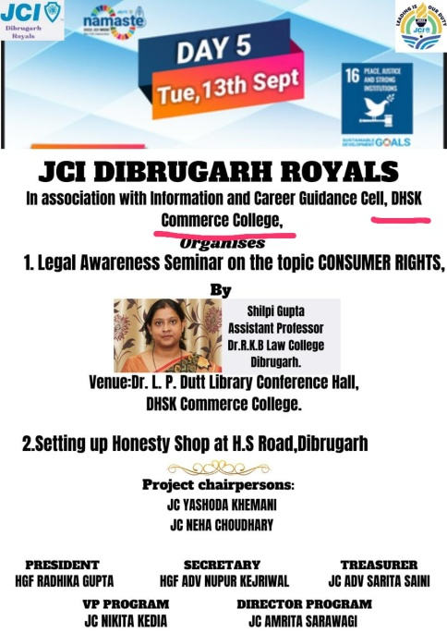
3 | 9th Feb, 2023 | NEW-AGE SKILL-SETS for a successful Career- a Career Counseling program for final semester students in association with Pune Institute of Business Management (PIBM); Speaker: Mr. Zulfi ALi Bhutto. | 44 | 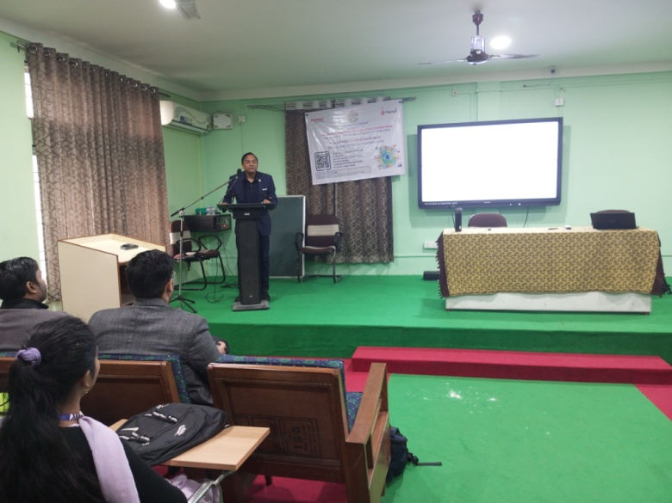
4 | 6th-13th Feb, 2023 | GAIN EMPLOYABILITY AND BE FUTURE-READY -a week-long Employability Skills Training Programme for Female students organized in association with Mahindra Pride Class, Nandi Foundation. | 44 | 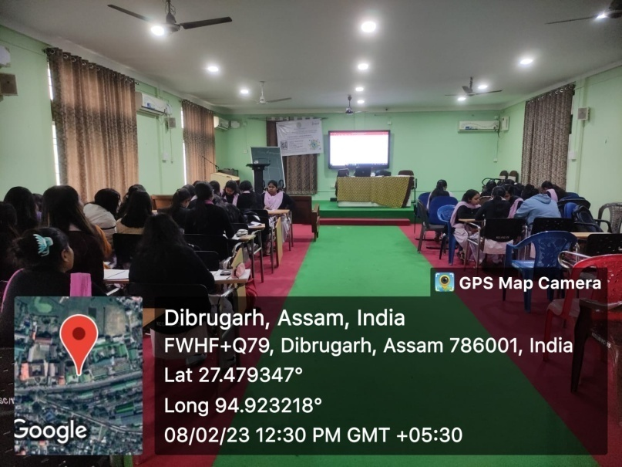
 | 21st Feb 2023 | CAMPUS PLACEMENT DRIVE organized by Times Pro in association with ICGC, DHSK Commerce College | 19 | 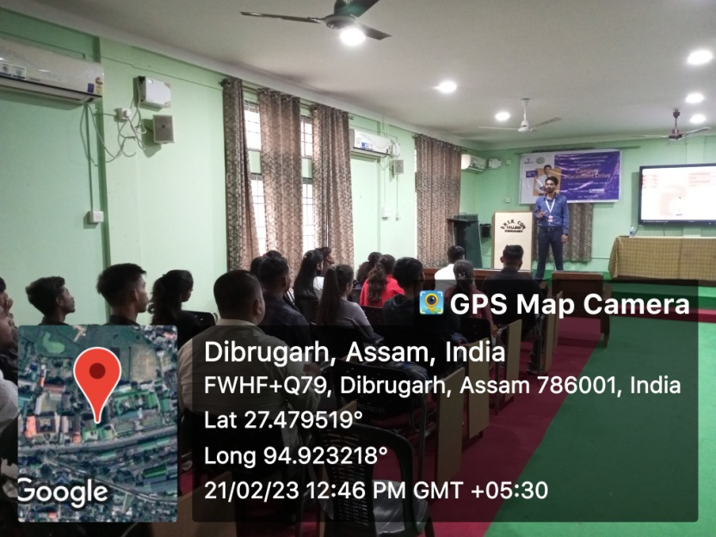
5 | 1st Apr-2023 | A Programme on career planning: A way ahead after B.Com. organized by ICGC, EOC, NSS and Gender Champions. Speaker: Mr. Veeru Singh Sokhi. | 100 | 