Report on Students’ Satisfaction Survey: 2019-2020
DHSK Commerce College

1.1 Speciality
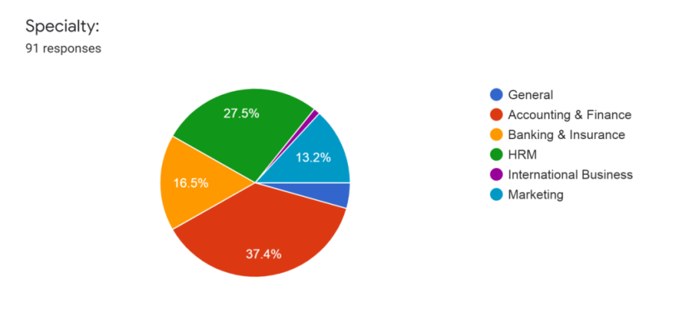

1.2 How much of your B.Com syllabus was covered in your last session?
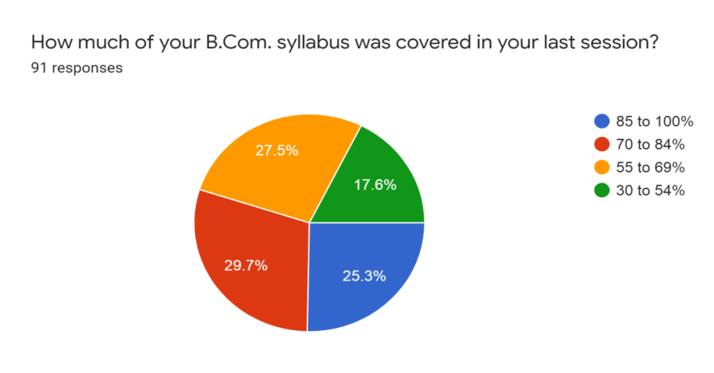
1.3 How well did the teachers prepare for the classes?
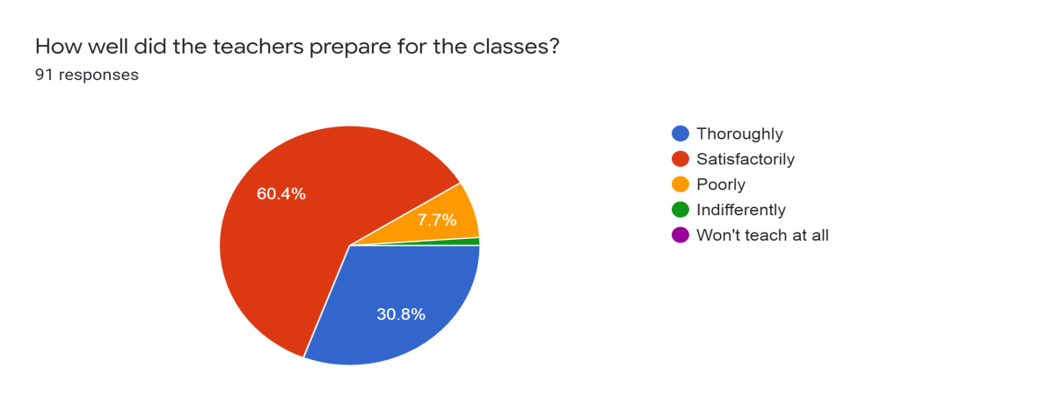

1.4 How well were the teachers able to communicate?

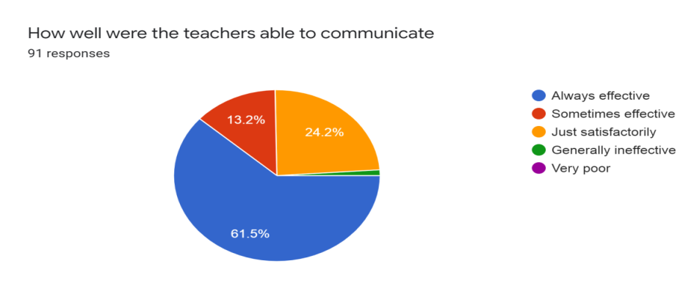

1.5 Teachers’ approach to teaching can be best be described
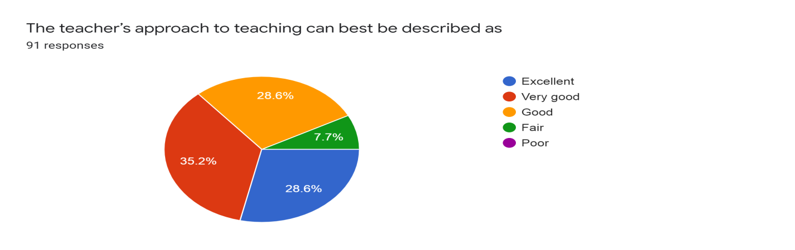
1.6 Fairness in the interval evaluation process by the teachers
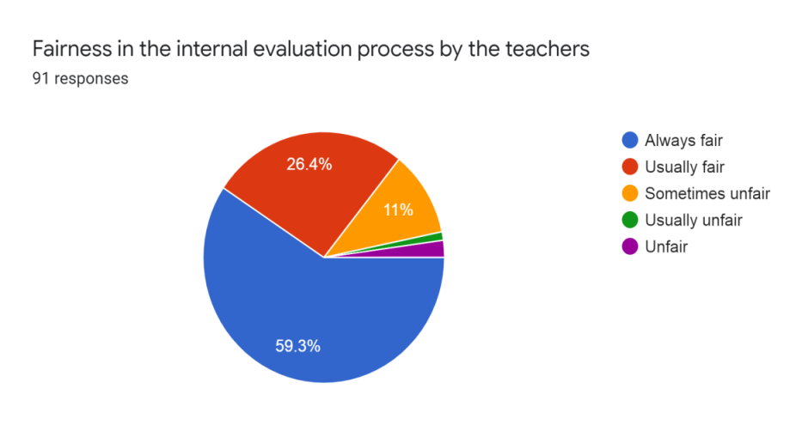
1.7 Discussion of the performance in assignment with the students.
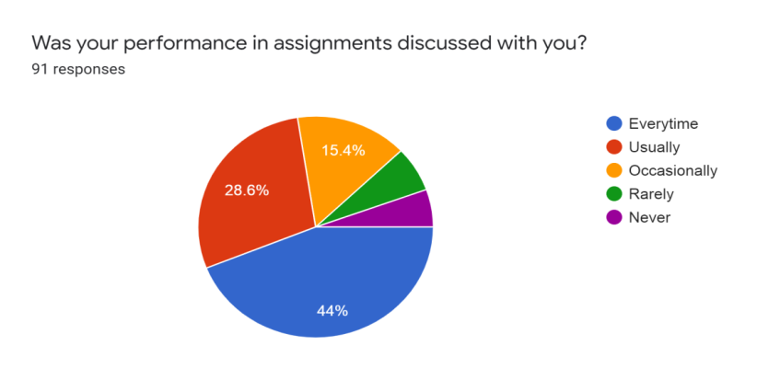

1.8 Initiatives taken by the college in promoting internship, students exchange, field visit, excursion, opportunities for students
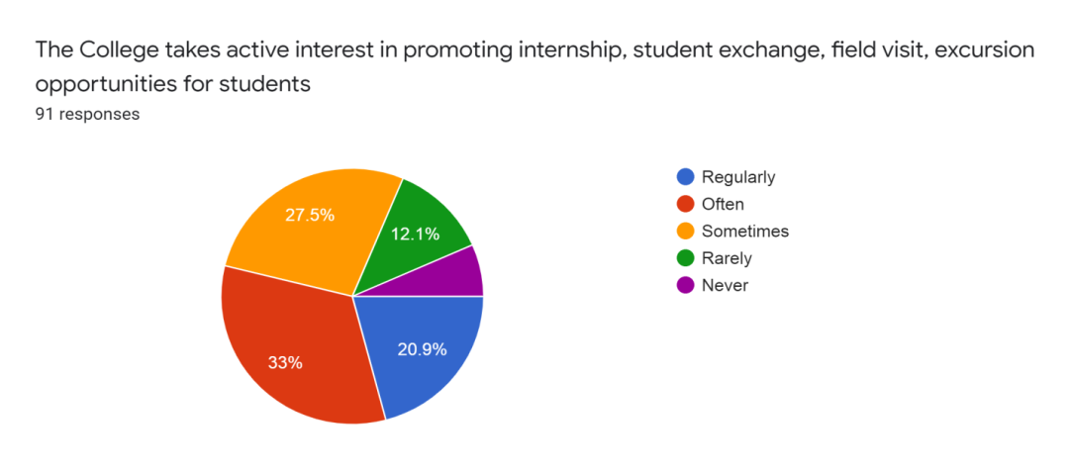
1.9 Teaching and mentoring process in the college

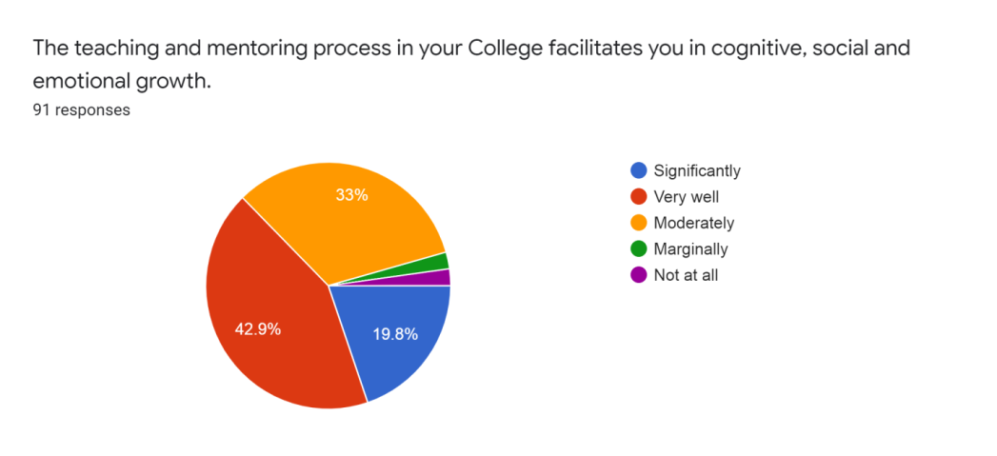

1.10 Information on course outcome

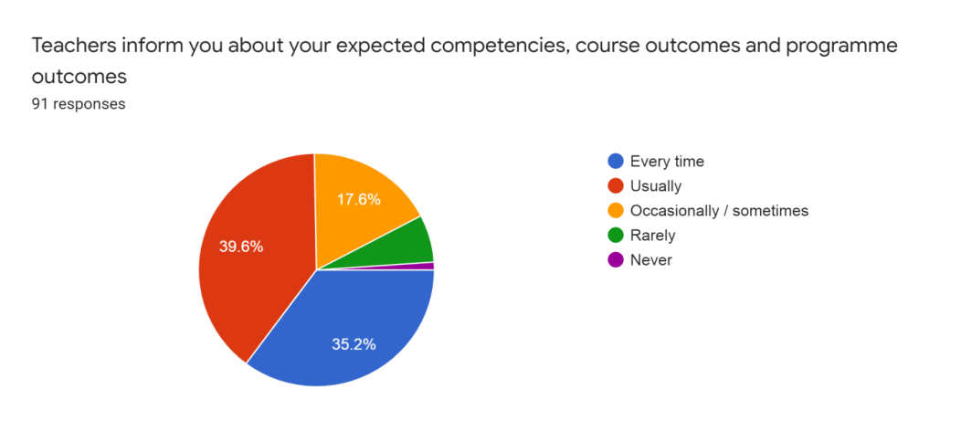

1.11 Follow-up by teachers
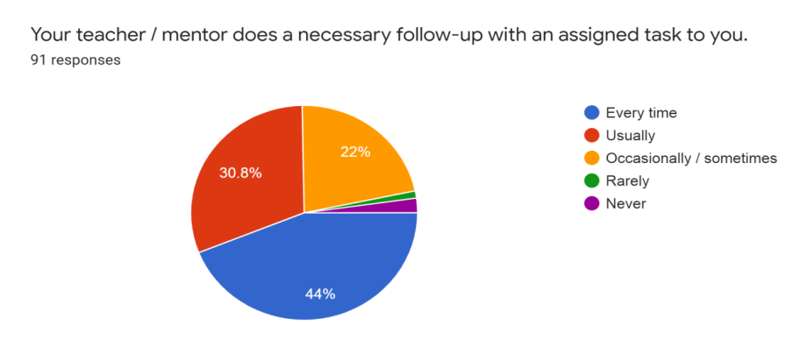

1.12 Identification of strength and encourage
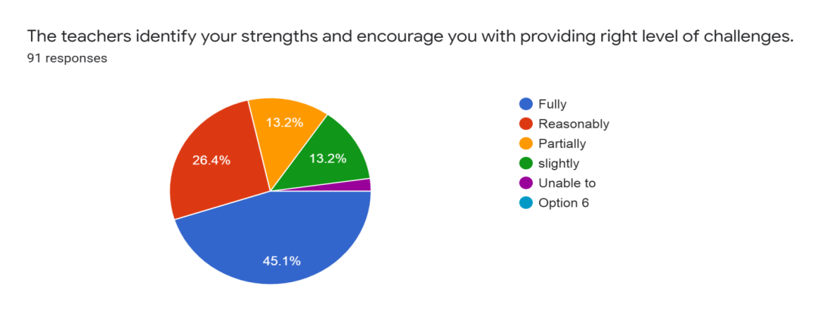
1.13 Identifying weakness and measures to overcome
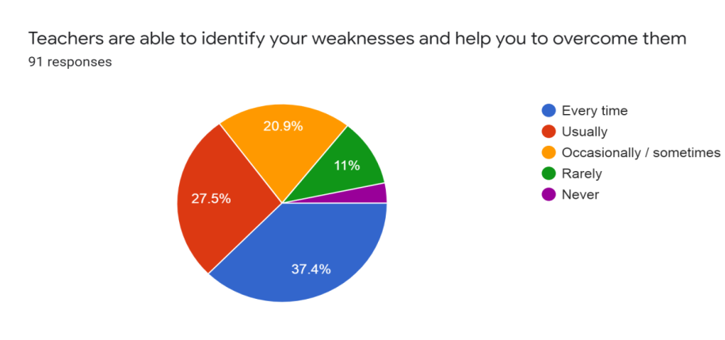
1.14 Continuous quality improvement of the teaching learning process.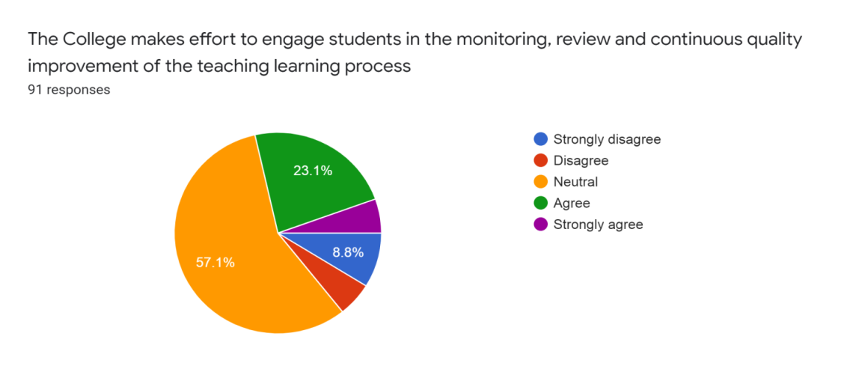

1.15 Use of students centric methods for enhancing learning experiences.
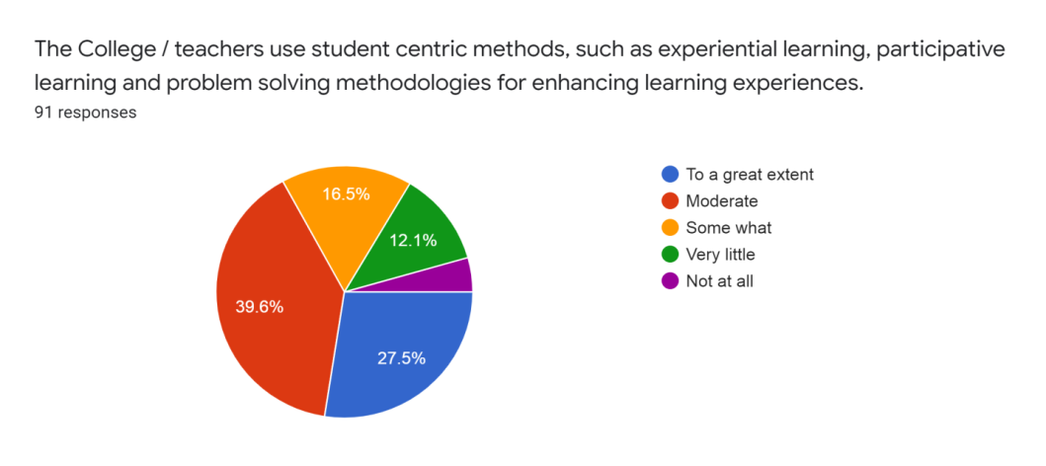

1.16 Inculcation of soft skill among the students
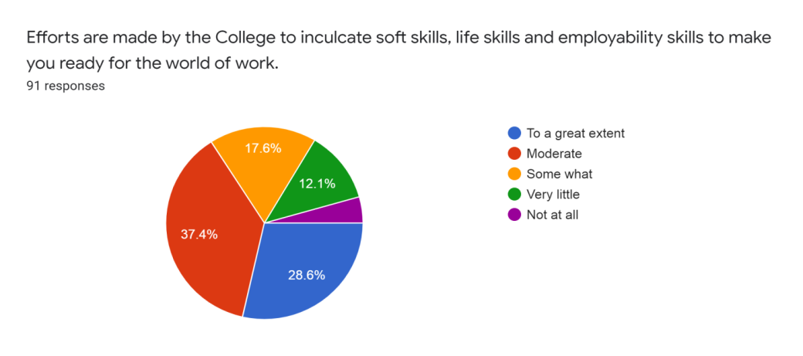
1.20 How do you find the DHSK Commerce College’s administrative offices?
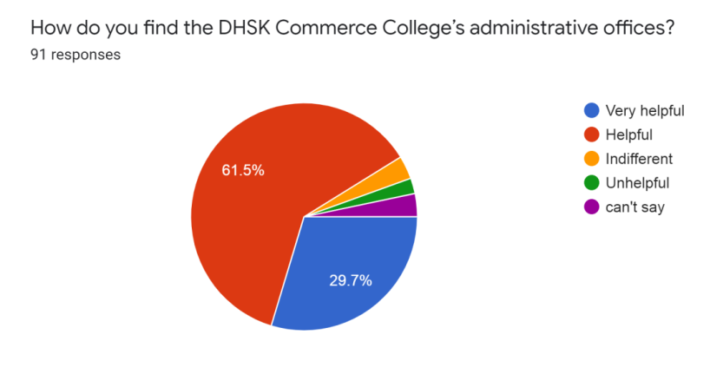
1.21 Percentage of teachers using ICT tools and techniques.
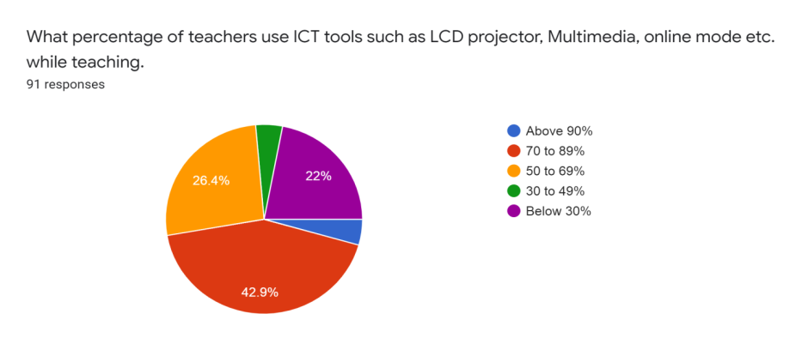
1.22 Participation in extracurricular activities.
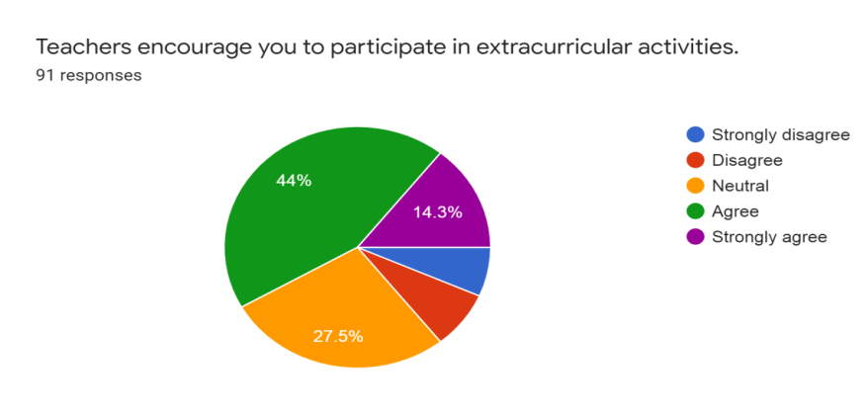

1.23 Overall facility of DHSK Commerce College
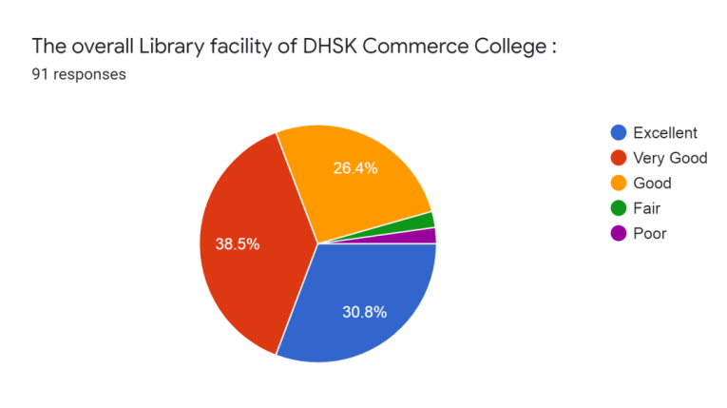
1.24 Computer and internet facilities of DHSK Commerce College
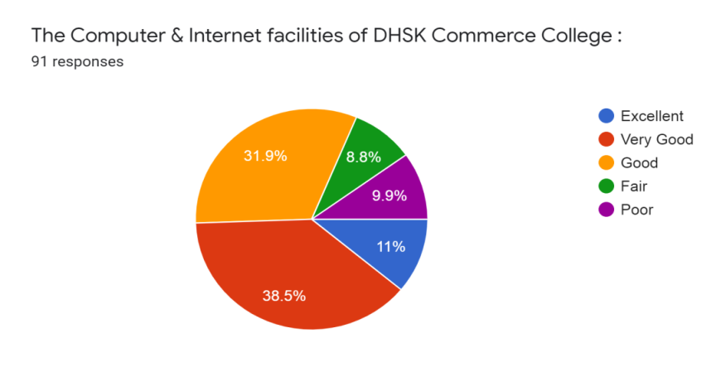

1.25 Canteen and drinking water facility of DHSK Commerce College
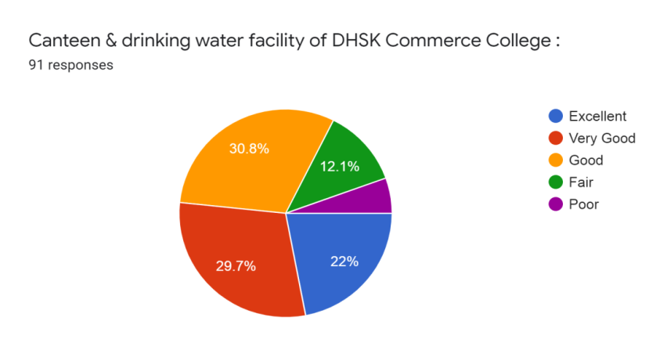

1.26 NCC & NSS
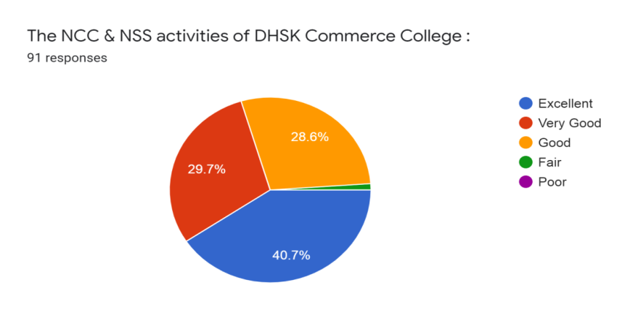
1.27 Boy’s / Girl’s Common facility
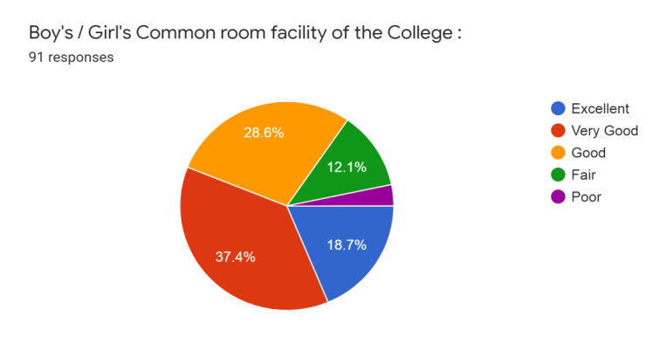

1.29 Free admission system & scholarship facility
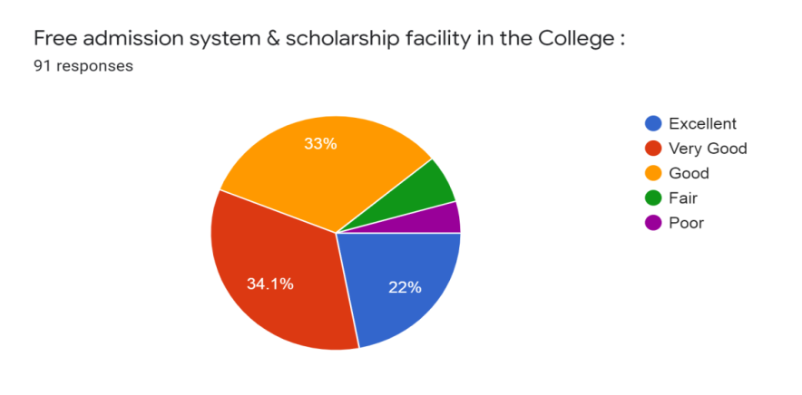
1.30 Overall cleanliness in the college
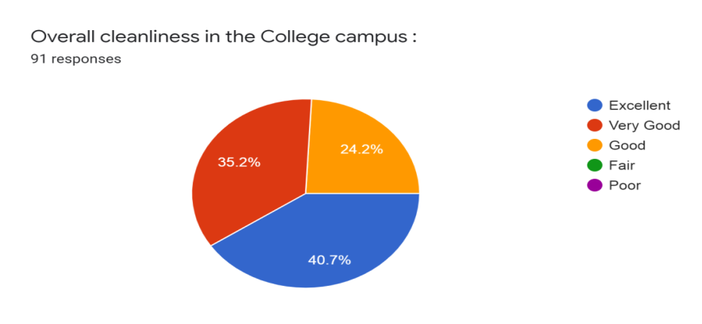
Observation: The report is the result of the satisfaction survey that was carried out to address various issues relating to the curriculum, infrastructure and other aspects within the college campus. A positive result was observed as majority of the students were satisfied with the aspects on which the survey was carried out. The above figures depicts the satisfaction level of the students on various aspects. However some of the suggestions and recommendations were put forwarded by the students which are mentioned below:

Suggestion and Recommendations:

- To start internship programmes
- To carry on programs on soft skill, life skill and activities related employability skills based on current scenario.

