Report on Teachers Feedback: 2019-20
DHSK Commerce College

1.1 Current Undergraduate syllabus of Dibrugarh University is need based

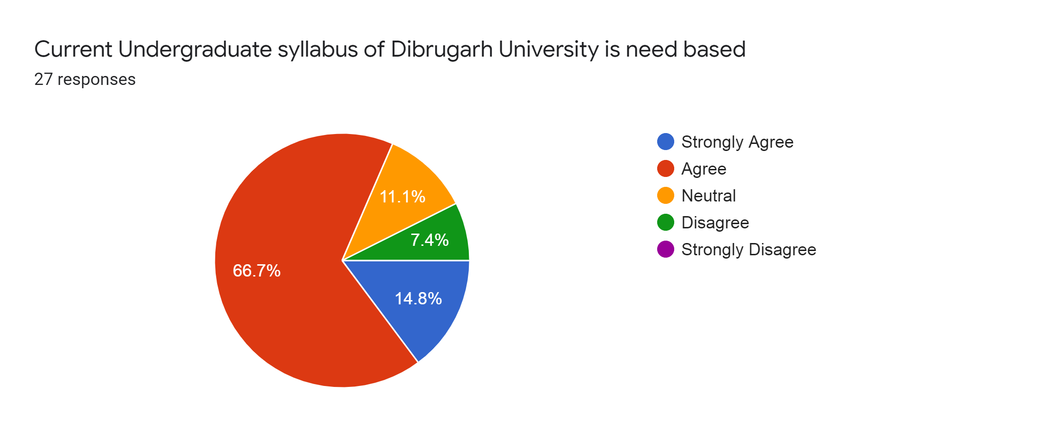
1.2: The curriculum have current content
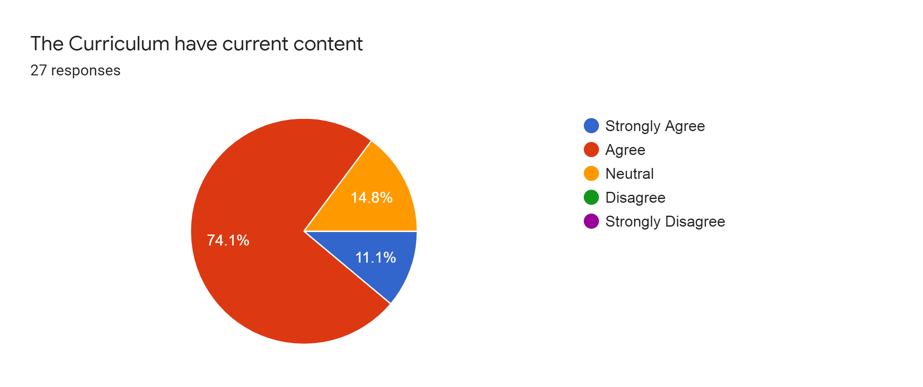

1.3 Programmes Outcome of the Syllabi is well defined:
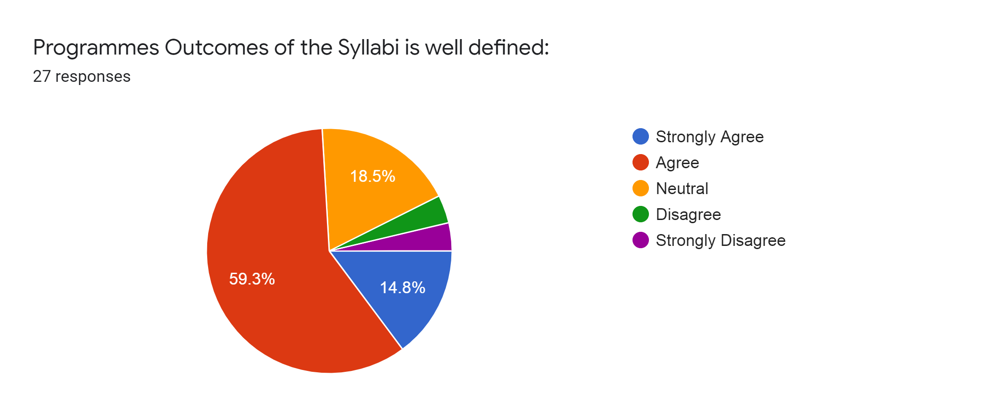

1.4: The curriculum have good academic flexibility
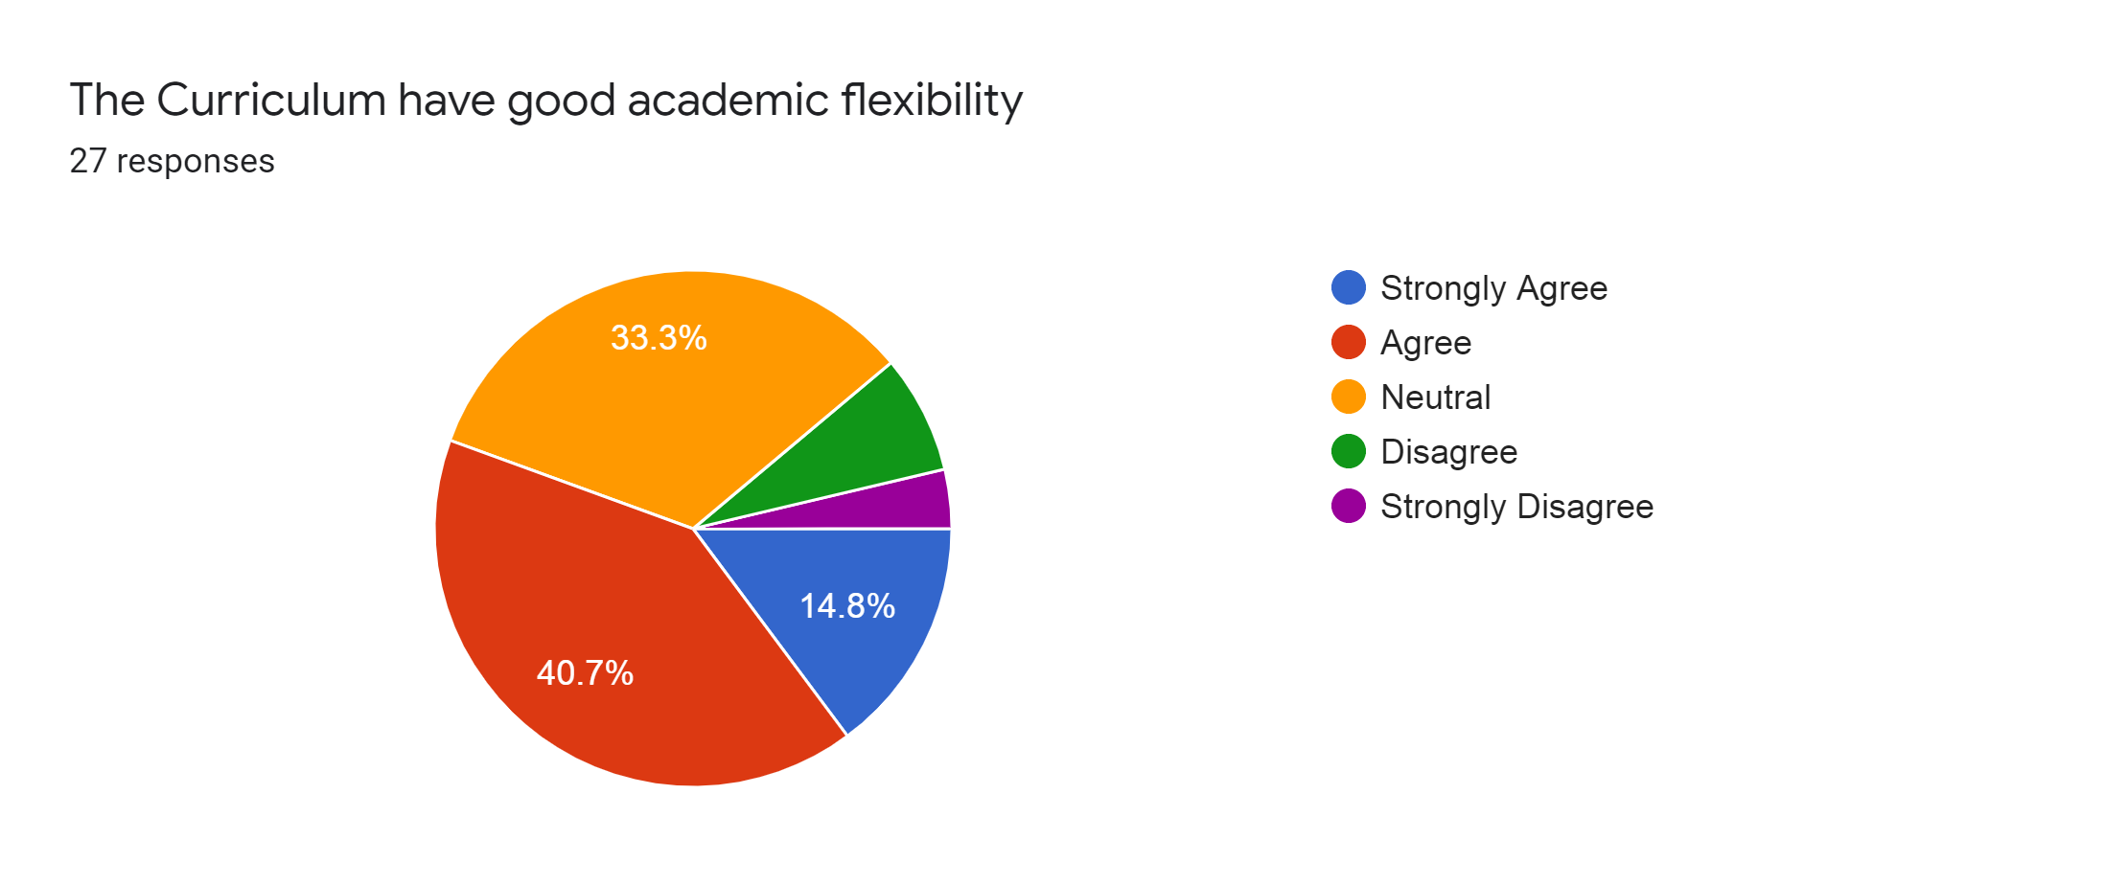

1.5: The course content fulfils the need of students
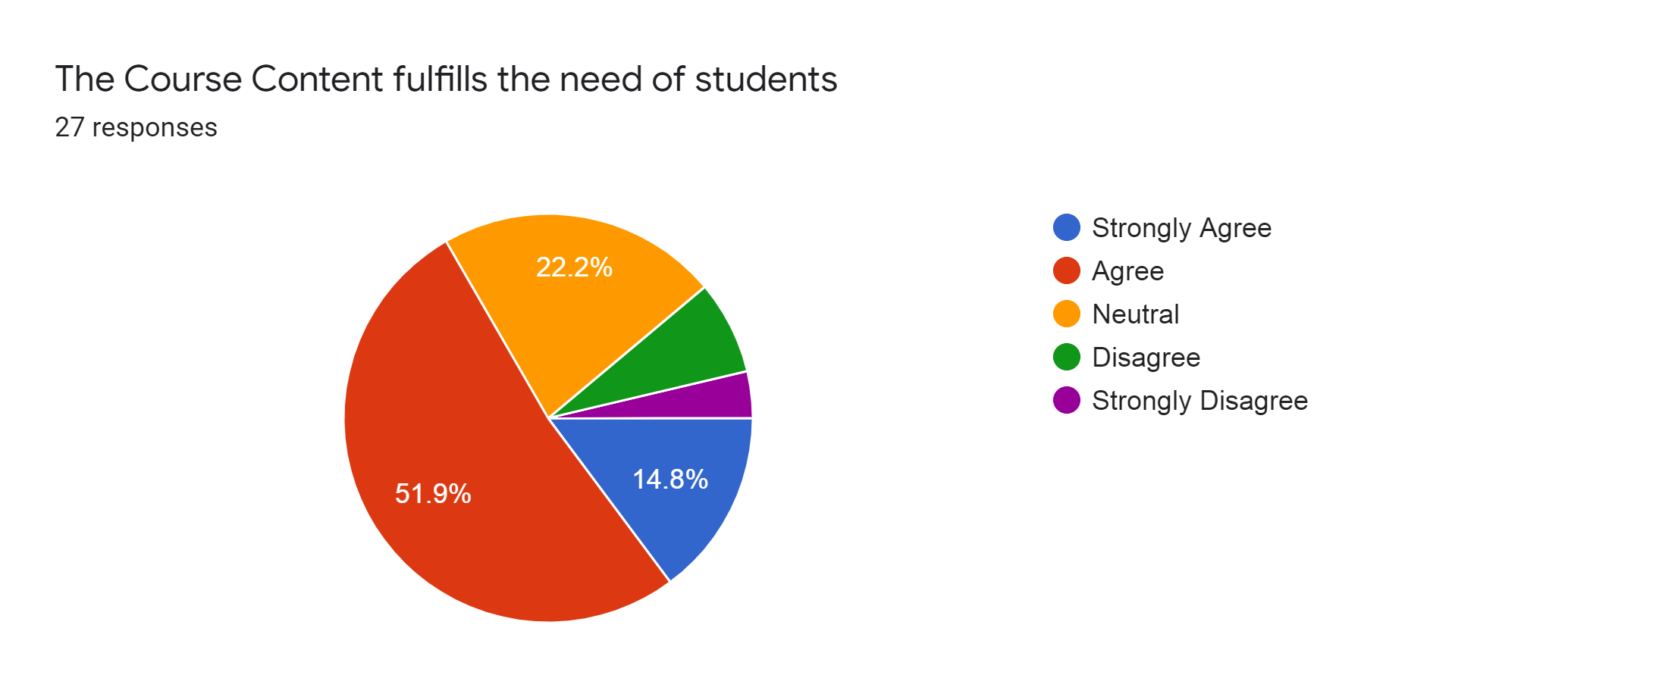

1.6 sufficient text & reference books are available in the college Library & Department
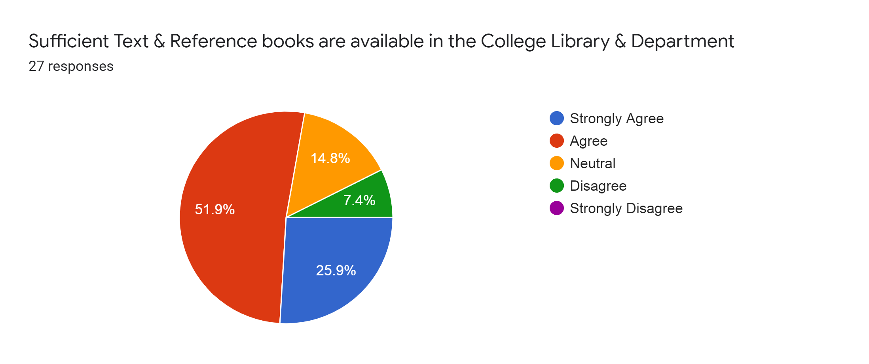

1.7: Information and communication Technology (ICT) facilities in the college are adequate and satisfactory
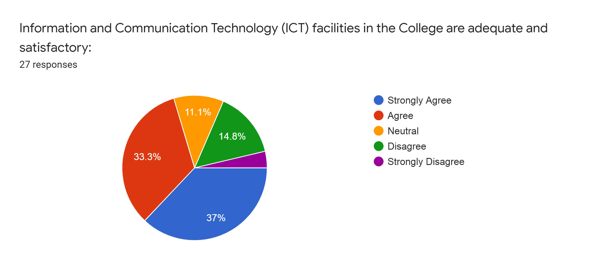

1.8 The environment in the college is conducive to teaching, learning research and extension activities.
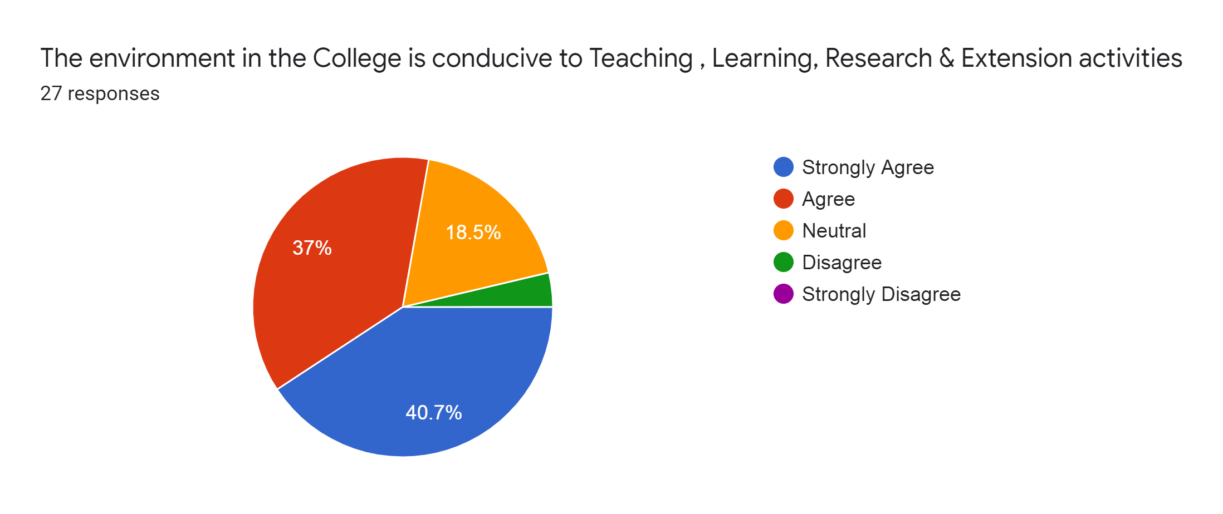

1.9 College administration is teacher friendly
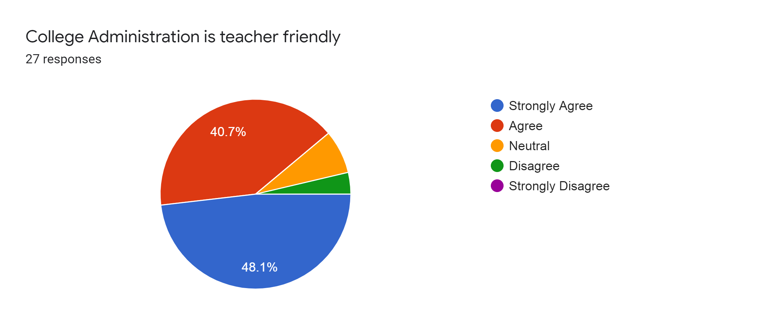

2.0 College provides adequate opportunities and support to faculty member for upgrading their skill and qualification.
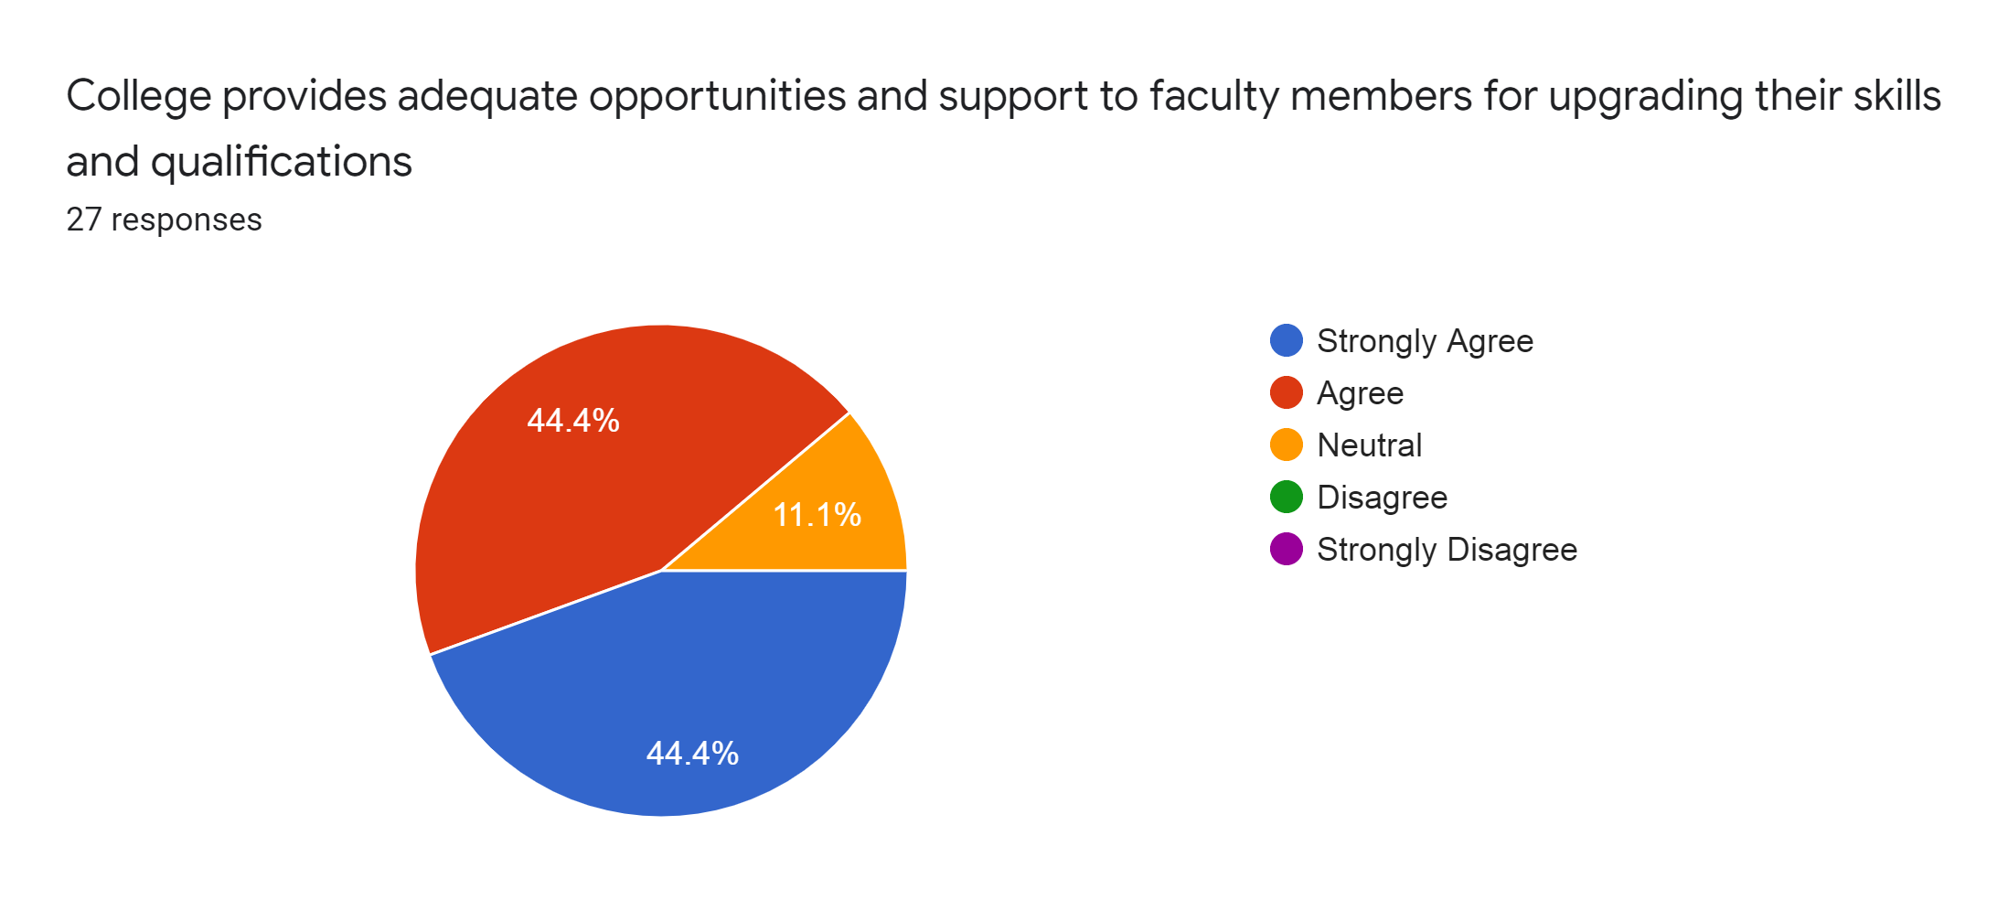

Observations: The report is the result of the feedback that was carried out to address various issues relating to the curriculum, infrastructure and other aspects within the college campus. A positive result was observed as majority of the teachers were satisfied with the aspects on which the survey was carried out. The above figures depicts the satisfaction level of the teachers on various aspects.

